2.43: a) Using the method of Example 2.8, the time the ring is in the air is
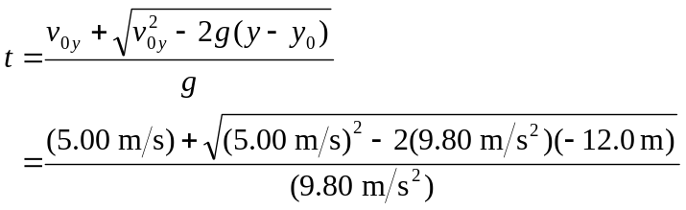
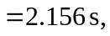
keeping an extra significant figure. The average velocity is then 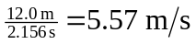, down.
As an alternative to using the quadratic formula, the speed of the ring when it hits the ground may be obtained from 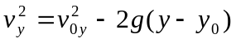, and the average velocity found from 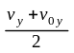; this is algebraically identical to the result obtained by the quadratic formula.
b) While the ring is in free fall, the average acceleration is the constant acceleration due to gravity, 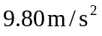down.

c) 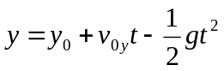
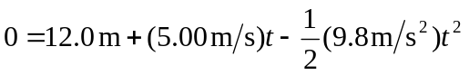
Solve this quadratic as in part a) to obtain t = 2.156 s.

d)
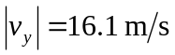

e)
